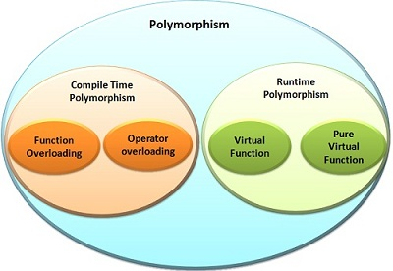

The virtual function and pure virtual function both are the concepts of run time polymorphism. Polymorphism is supported by both the languages C++ and Java. In Java, the term “overriding” is used instead of ‘virtual function’, as the virtual function is the term of C++.

The main difference between ‘virtual function’ and ‘pure virtual function’ is that ‘virtual function’ has its definition in the base class and also the inheriting derived classes redefine it. The pure virtual function has no definition in the base class, and all the inheriting derived classes has to define it.